**Overview**

The Information Technology Sector, more commonly referred to as Technology Sector, comprises businesses that offer software and information technology services, manufacturers and distributors of technology hardware & equipment such as communications equipment, cellular phones, computers & peripherals, electronic equipment and related instruments, and semiconductors (as defined by GICS).

Global Industry Classification Standard (GICS) is a four-tiered, hierarchical industry classification system based on market perception, quantitative & qualitative factors. It consists of 11 Sectors, 24 Industry Groups, 69 Industries and 158 Sub-Industries. The GICS methodology is widely accepted as an industry analytical framework for investment research, portfolio management and asset allocation.

**S&P 500 Index Sector Breakdown:**

**S&P 500 ESG Index Sector Breakdown:**

**Top 10 constituents of the S&P 500 Information Technology Index (by market cap):**

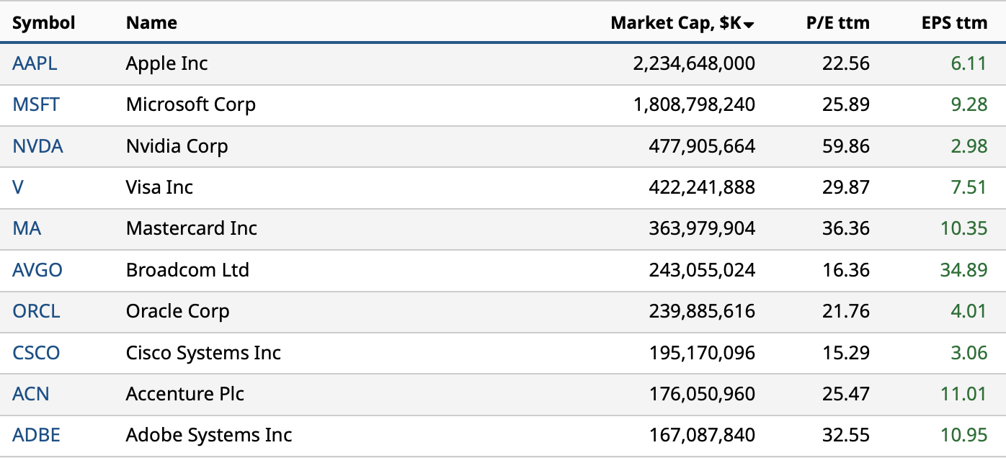

Source: (pie charts) S&P 500 Factsheet – S&P Global, Dec 2022; (constituents ranking) Barchart.com, Jan 2023

The Technology sector is the largest of the 11 GICS sectors in the S&P 500 & S&P 500 ESG indices, accounting for **25.7%** & **28.3%** of the overall indices respectively. It has 3 major Industry Groups which are further classified into 6 industries and 13 sub industries as described below.

**Software & Services: (Code 4510)**

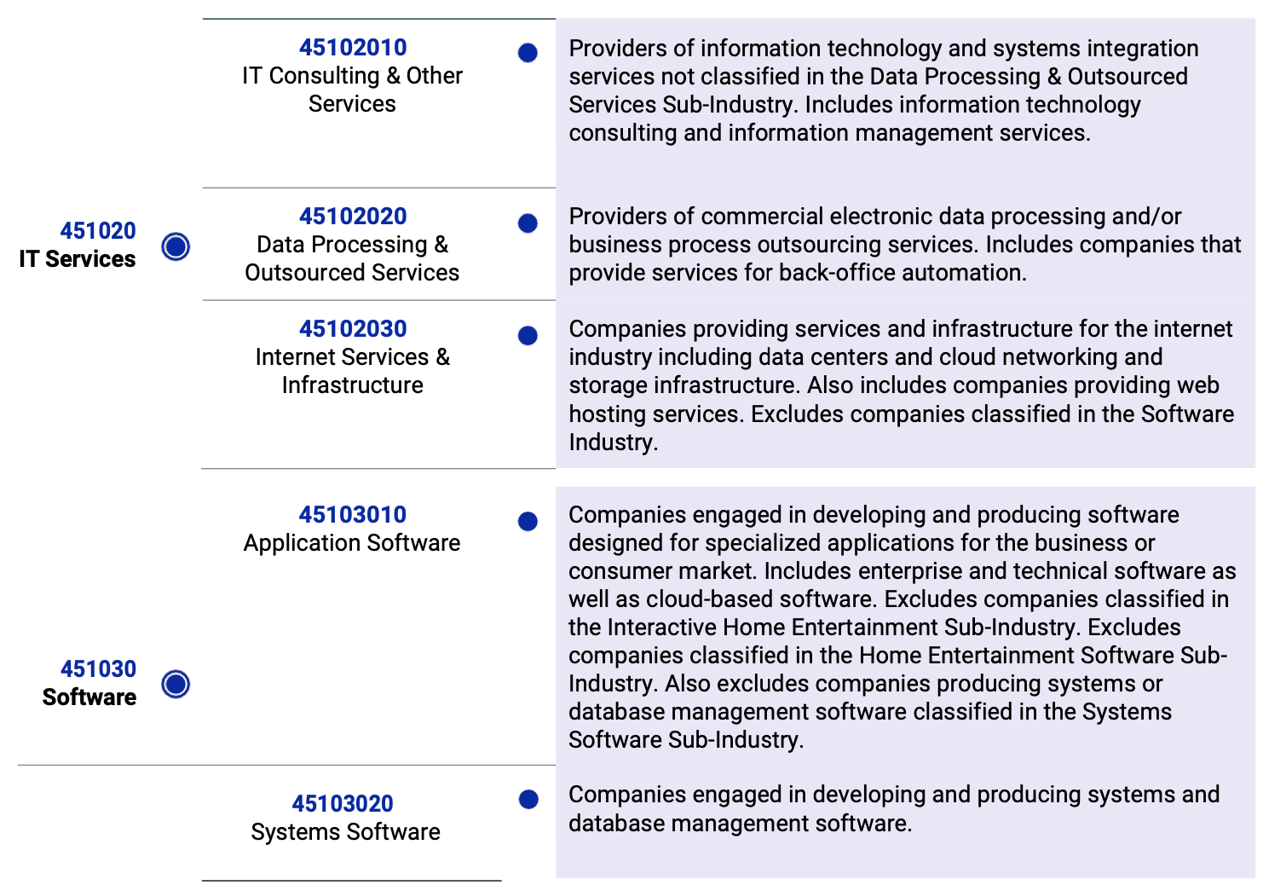

**Technology Hardware & Equipment: (Code 4520)**

**Semiconductors & Semiconductor Equipment: (Code 4530)**

Source: GICS Methodology, Jan 2022

**Sector Performance in the past 12 months (LTM)**

As with most other GICS sectors, 2022 was but a challenging year for the Information Technology sector too. The S&P 500 Information Technology index value was down by about **27.6%** at the end of calendar year 2022 before recouping in the first three weeks of 2023 to trade at current levels, which is still down by **12.54%** from its value twelve months ago (LTM).

**Fundamentals:**

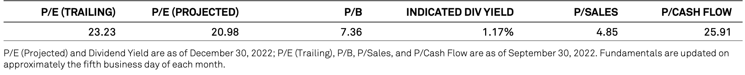

Source: S&P Global, Dec 2022

**SWOT Analysis: (drivers of sector performance)**

**Opportunities**

* Quantum Computing – potential to fuel breakthroughs in areas such as drug discovery & climate change
* Rise of Hybrid Data Storage trend and move to 5G wireless networks

**Strengths**

* Advances in AI capabilities led to increased business adaptability across sectors
* Rapid & wide-spread digitization being adopted by businesses across sectors

**Weaknesses**

* Macro factors led to slow revenue growth in application software, largely bringing down valuations
* Concerns over shortage of tech talent & difficulty in hiring for specialized roles

**Threats**

* Short-term reduced business spending on technology infrastructure to cut costs
* Challenges including investor anxiety related to high inflation & rising interest rates

**Sector Highlights:**

* **Growth vs Value** – Growth Stocks are defined as those with 5-year average sales growth above 15%, whereas Value Stocks are those with price-to-sales below 1. The Tech sector generally tends to be titled toward growth factor. However, over the past two years, value factors have performed quite well in the historically growth-oriented Tech sector.

Source: Charles Schwab, Piper Sandler, Bloomberg, as of Oct 2022

* **Microchip Customisation** – The debate between fab & fabless has spurred on ever since the news of giants like Apple, Amazon & Tesla stated to make their own chips hit the market. However, it’s important to mention that this means they will focus on customising chip designs to better fit their requirements and not necessarily manufacturing chips themselves. This change affects fabless companies that supplied giants like Apple & Tesla with chips and do not put them in direct competition with chip giants like Nvidia, AMD & Intel. Foundries like TSMC are the potential benefactors, however.

**Sector Performance Outlook over the next 12 months (NTM)**

While the Tech sector outperformed during the pandemic pressures of 2020-21, the sector led considerable stock market declines in 2022. A major challenge now for tech companies is how to weather a potential economic slowdown by trimming costs, increasing efficiency, and growing revenues. Some key themes playing a critical role for the next twelve months are included below:

* **Leading through Macroeconomic uncertainty** – Weakened consumer spending, lower product demand and falling market capitalisations have led tech companies to focus on increasing margins. Beyond workforce adjustments, approaches may include making business processes more efficient, reducing tech debt by implementing best practices for software development, modernising legacy architectures by migrating to cloud & XaaS, and considering strategic M&A.
* **Navigating global uncertainties** – As the tech sector grapples with heightened global challenges-including geopolitical tensions, supply chain volatility, raw material shortages, semiconductor supply concerns and new regulations-they are anticipated to work toward mitigating risks and building more resilient systems.
* **Strategic importance of digital transformation** – Wider adoption of cloud computing, AI and IoT continue as businesses strive to cut costs and make better decisions. On a hunt for new revenue opportunities, the tech sector is extending its reach into other industries such as healthcare & agriculture, using digital advancements to support innovation and transformation.
* **New Regulations** – Climate change & social impacts are having an increasing effect on the operation of tech companies. In addition, governments & shareholders are pushing companies to heighten transparency around their tax liabilities, environment footprints and to commit to reducing carbon emissions. These new & proposed regulations require them to update business management software tools so as to adhere to complex compliance processes about data visibility.
* **Valuations** – Valuations look compelling. According to analysts’ estimates, the average enterprise value to NTM estimated sales ratio for North American software stocks to be nearly back to 6x.
* **Inflation & Interest rates** – As per the latest stats, inflation seems to be on a downward trend, having declined in the last two months from its October peaks, warranting the rate increases by the US Federal Reserve. In addition, longer duration real yields seem to have arguably peaked. So even as the Fed continues to raise interest rates, valuations should not necessarily decline further. However, growth is again expected to become scarce, likely leading investors to gravitate back to quality growth.

**Analysts’ forecasts for sector**

The outlook for the technology sector in 2023 is difficult to assess, given the significant macroeconomic and geopolitical headwinds. However, according to BNP Paribas Asset Management, secular growth drivers that underpin their investment strategy – cloud computing, artificial intelligence (AI), automation, and the Internet of Things (IoT) – as well as the foundational technologies that enable these themes will deliver superior revenue growth, earnings, cash flows, and returns over a long-term investment horizon.

While negative earnings revisions are likely as the economy slows, most analysts see potential for the sector to outperform on a relative basis, given the historical resilience of tech profits during recessions. As growth becomes scarcer, investors may once again be willing to pay up for quality and sustained growth.

Specifically, Gartner forecasts 5% growth in IT spending in 2023, calling Cybersecurity as one of the key areas to look out for the next twelve months.

So, while the long term view for the sector is bullish, we recommend maintaining a hawkish stance in the near term.

**References**

**S&P 500 Resources:**

* [S&P 500](https://www.spglobal.com/spdji/en/indices/equity/sp-500/#overview) – S&P 500 index data and factsheet
* [S&P 500 ESG](https://www.spglobal.com/spdji/en/indices/esg/sp-500-esg-index/#overview) – S&P 500 ESG index data and factsheet
* [S&P 500 Information Technology](https://www.spglobal.com/spdji/en/indices/equity/sp-500-information-technology-sector/#overview) – S&P 500 Information Technology sector index data and factsheet

**Other Essential Research Resources:**

* [MSCI - GICS](https://www.msci.com/our-solutions/indexes/gics) – Details about GICS methodology and constituents
* [Financial Times](https://buselrn.ucd.ie/our-services/financial-times/) – Articles and latest market trends and insights from the FT news feed
* [Barchart](https://www.barchart.com/stocks/indices/sp-sector/information-technology?viewName=fundamental) – sector specific data & graphics
* [Deloitte Market Research](https://www2.deloitte.com/us/en/pages/technology-media-and-telecommunications/articles/technology-industry-outlook.html) – Market trends research and outlook by Deloitte
* [BNP Paribas Asset Management](https://www.bnpparibas-am.com/en/portfolio-perspectives/investment-outlook-2023-investing-in-an-age-of-transformation/) – Investment Outlook 2023
* [McKinsey Digital](https://www.mckinsey.com/capabilities/mckinsey-digital/our-insights/tech-highlights-from-2022-in-eight-charts) - Tech highlights from 2022
* [Charles Schwab](https://www.schwab.com/learn/story/growth-vs-value-what-does-it-mean) - Growth vs Value for Tech sector